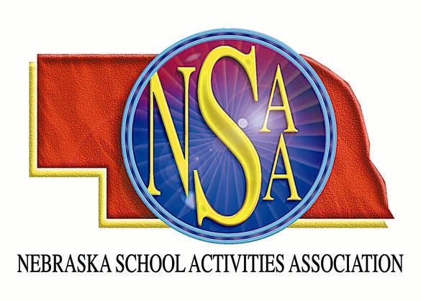

2007 SHRINE BOWL APPLICATION

The Shrine Bowl of Nebraska is accepting applications to officiate the 2007 game, which will be played at Memorial Stadium, in Lincoln, on Saturday, July 21st at 6:30 pm. The committee will select the Referee, Umpire and a Linesman/Line Judge to work the 2006 game. The Omaha and Lincoln officials associations will select a Back Judge and the other Linesman/Line Judge. Any certified football official who has never worked a Nebraska Shrine Bowl may apply. To request an application, e-mail Steve Nelson at: SteveN@FBFS.com. Applications must be submitted by October 27, 2006.

